EXPERIMENT- 35
Morphological Operations using Black Hat Technique
Aim
To write a Python code to perform Black Hat transformation using OpenCV for highlighting dark regions in the image.
Code
from google.colab import files
import cv2
import numpy as np
from google.colab.patches import cv2_imshow
uploaded = files.upload()
image_path = list(uploaded.keys())[0]
image = cv2.imread(image_path, cv2.IMREAD_GRAYSCALE)
kernel = np.ones((5,5), np.uint8)
black_hat = cv2.morphologyEx(image, cv2.MORPH_BLACKHAT, kernel)
cv2_imshow(image)
cv2_imshow(black_hat)
Input & Output Image
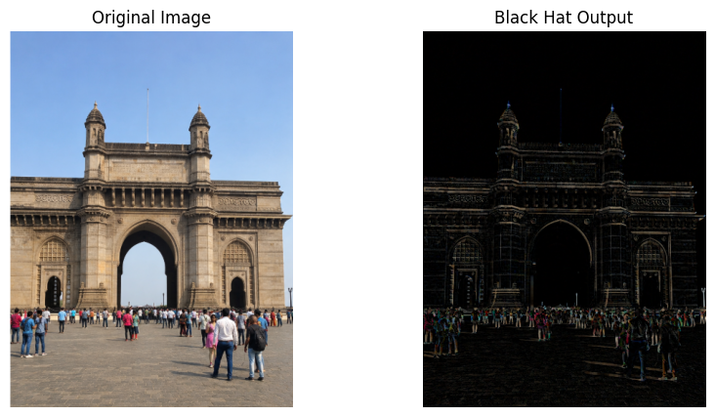
Result
Thus, the Black Hat transformation was successfully performed using OpenCV.

